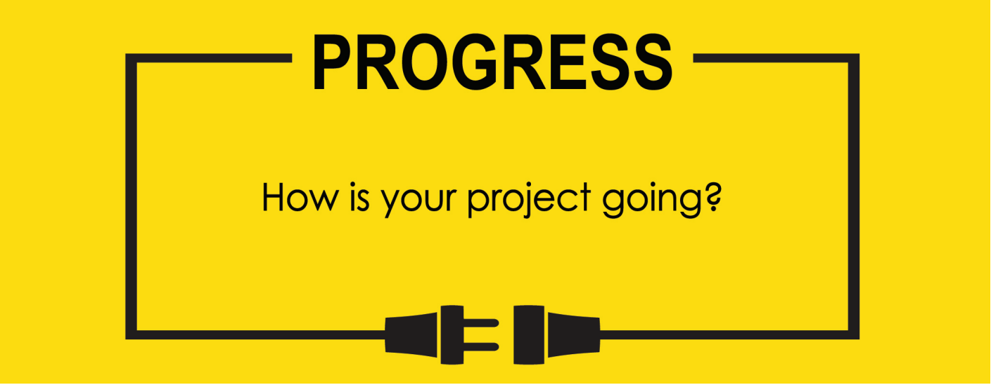

**Name: Zach Wilcox**

**Project Title: GreenBox**

**Previous Goals**

What were your three goals from last week? Were you able to complete them? If so, select Completed. If not, select the level of completion and explain in the Notes section why the goal was not completed, what still remains to be done, and when you expect to finish work on the goal.

Goal #1 from last week: Finish box build

**Status:** _____Completed __x___Partially Completed _____No Progress

**Notes:**

I don’t quite feel good saying it’s finished yet, but there are only minor fixes and tweaks left before it is. It needs sanding all-over and flame-polishing as well as a more secure way to mount the electronics into their places.

Goal #2 Finish input/output software

**Status:** __x___Completed _____Partially Completed _____No Progress

**Notes:**

Unfortunately, I couldn’t stop the temperature/humidity sensor from acting up. I was also having issues with the display not sizing the fonts quite right, so I have done both functions on an Arduino that will communicate the measurements to the microcontroller via UART. It is not a perfect solution, but it had to happen to be able to move on before time ran out.

Goal #3 Test input/output software

**Status:** __x___Completed _____Partially Completed _____No Progress

**Notes:**

Since the I/O portions of software that were not working correctly are being run on the Arduino then passed to the microcontroller, the I/O portions of code are working completely as intended.

**Next Three Goals**

Choose three subtasks from your Gantt chart and use them to form goals that you plan to complete this week. In the text box beneath each goal, give details about what you plan to accomplish. Include details such as what materials are needed, how many hours each day you plan to devote to the task, and so on.

NOTE: THESE ARE INDIVIDUAL GOALS THAT YOU PLAN TO ACCOMPLISH. THESE ARE NOT TEAM GOALS.

**Goal #1:** Finish project.

**Goal #2:**

**Goal #3:**

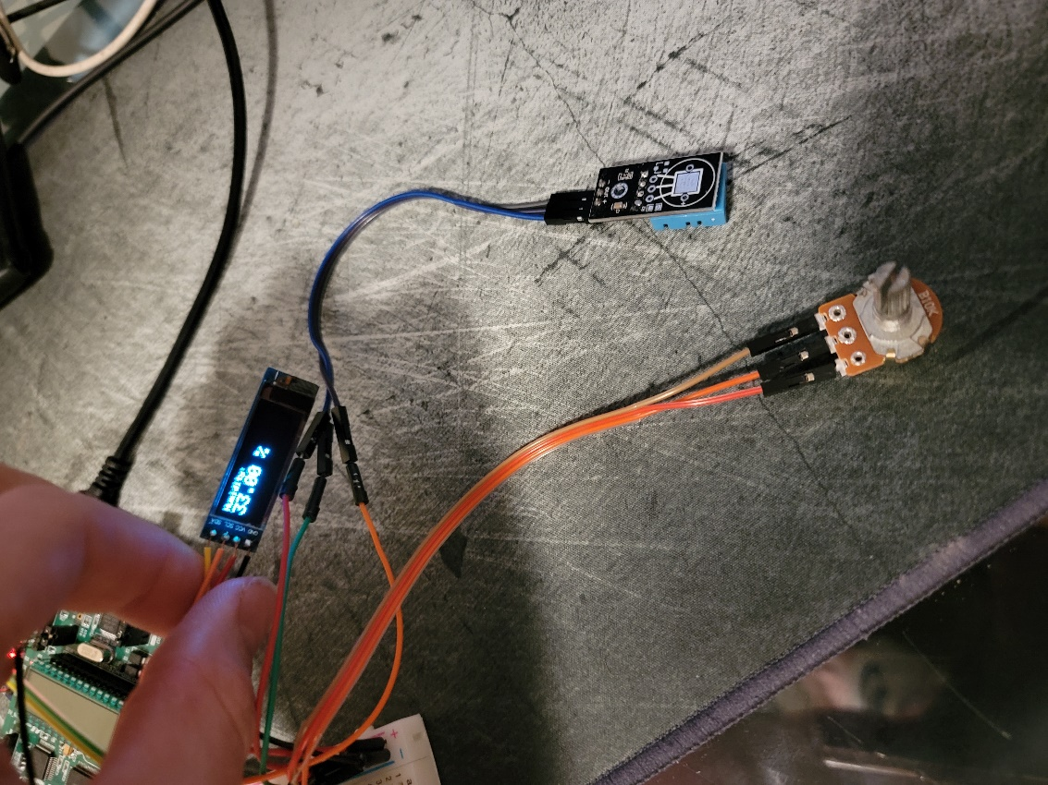

Gantt Chart has not changed

